Chapter 8 – Chemical Reactions and Physical Changes

*The Cycle of Change*-

**Chemical Reactions** – change one substance into another substance.

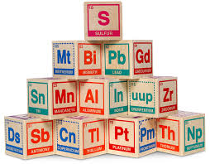 ***Atoms***-

Building blocks of matter

Smallest particle of an element that retains its chemical properties

*Structure of Atoms*

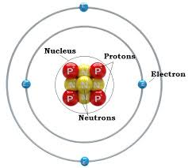 **Nucleus** – dense core of an atom

**Protons** – positively charged particle

**Neutrons**-uncharged particle

` **Electrons**- negatively charged particle

***Atomic Mass***-an average mass of a sample of atoms of that element

***Mole***- unit of measure used to count atoms or molecules

*How Compounds Form*

**Chemical bonds** *–* the forces that hold atoms together

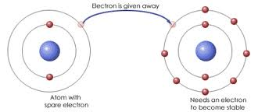**Ionic bonding**-the bond formed by the transfer of electrons between atoms

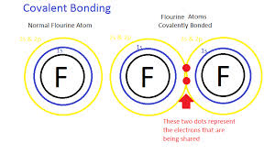**Covalent bonding**- atoms share electrons with each other

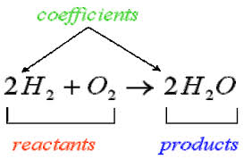**Chemical Equation** – written description of a chemical reaction using symbols and formulas

**Products** – elements or compounds formed during the reaction

**Physical change** – alters the properties of a substance, such as shape, size and phase. It does not change its chemical composition.

**Freezing** – liquid to a solid

**Melting** – solid to a liquid

**Vaporization** – liquid to a gas

Reversible Physical Changes –

Some Physical changes that are reversible are solutions. Salt and sugar solutions

Others are not, such as baked products